**ЛАБОРАТОРНАЯ РАБОТА №7**

Основные понятия теории графов.

Автор работы

студент 2 курса

группы ИВТ(1) подгруппы 2

Ефимова В.С.

**Постановка задачи:**

Составьте матрицы инцидентности и смежности для следующих графов:

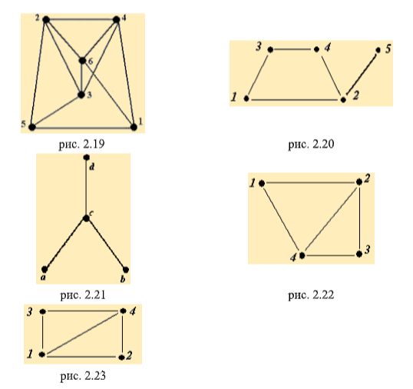

**Решение задачи:**

1.

Матрица идентичности

|  |  |  |  |  |  |  |  |  |  |  |  |
| --- | --- | --- | --- | --- | --- | --- | --- | --- | --- | --- | --- |
|  | A | B | C | D | E | F | G | H | I | J | K |
| 1 | 1 | 1 | 0 | 0 | 0 | 0 | 1 | 0 | 0 | 0 | 0 |
| 2 | 0 | 0 | 1 | 1 | 0 | 0 | 0 | 0 | 1 | 1 | 0 |
| 3 | 0 | 0 | 0 | 0 | 0 | 1 | 0 | 1 | 1 | 0 | 1 |
| 4 | 1 | 0 | 1 | 1 | 1 | 0 | 0 | 0 | 0 | 0 | 0 |
| 5 | 0 | 1 | 0 | 0 | 0 | 0 | 0 | 1 | 0 | 0 | 0 |
| 6 | 0 | 0 | 0 | 0 | 0 | 0 | 1 | 0 | 0 | 1 | 1 |

Матрица смежности:

|  |  |  |  |  |  |  |
| --- | --- | --- | --- | --- | --- | --- |
|  | 1 | 2 | 3 | 4 | 5 | 6 |
| 1 | 0 | 0 | 0 | 1 | 1 | 1 |
| 2 | 0 | 0 | 1 | 1 | 1 | 1 |
| 3 | 0 | 1 | 0 | 1 | 1 | 1 |
| 4 | 1 | 1 | 1 | 0 | 0 | 1 |
| 5 | 1 | 2 | 3 | 0 | 0 | 0 |
| 6 | 1 | 1 | 1 | 1 | 0 | 0 |

2.

Матрица идентичности:

|  |  |  |  |  |  |
| --- | --- | --- | --- | --- | --- |
|  | A | B | C | D | E |
| 1 | 1 | 0 | 0 | 0 | 1 |
| 2 | 1 | 1 | 1 | 0 | 0 |
| 3 | 0 | 0 | 0 | 1 | 1 |
| 4 | 0 | 0 | 1 | 1 | 0 |
| 5 | 0 | 1 | 0 | 0 | 0 |

Матрица смежности:

|  |  |  |  |  |  |
| --- | --- | --- | --- | --- | --- |
|  | 1 | 2 | 3 | 4 | 5 |
| 1 | 0 | 1 | 1 | 0 | 0 |
| 2 | 1 | 0 | 0 | 1 | 1 |
| 3 | 1 | 0 | 0 | 1 | 0 |
| 4 | 0 | 1 | 1 | 0 | 0 |
| 5 | 0 | 1 | 0 | 0 | 0 |

3.

Матрица идентичности:

|  |  |  |  |
| --- | --- | --- | --- |
|  | 1 | 2 | 3 |
| a | 1 | 0 | 0 |
| b | 0 | 0 | 1 |
| c | 1 | 1 | 1 |
| d | 0 | 1 | 0 |

Матрица смежности:

|  |  |  |  |  |
| --- | --- | --- | --- | --- |
|  | a | b | c | d |
| a | 0 | 0 | 1 | 0 |
| b | 0 | 0 | 1 | 0 |
| c | 1 | 1 | 0 | 1 |
| d | 0 | 0 | 1 | 0 |

4.

Матрица идентичности:

|  |  |  |  |  |  |
| --- | --- | --- | --- | --- | --- |
|  | A | B | C | D | E |
| 1 | 1 | 0 | 0 | 1 | 0 |
| 2 | 1 | 1 | 0 | 0 | 1 |
| 3 | 0 | 1 | 1 | 0 | 0 |
| 4 | 0 | 0 | 1 | 1 | 1 |

Матрица смежности:

|  |  |  |  |  |
| --- | --- | --- | --- | --- |
|  | 1 | 2 | 3 | 4 |
| 1 | 0 | 1 | 0 | 1 |
| 2 | 1 | 0 | 1 | 1 |
| 3 | 0 | 1 | 0 | 1 |
| 4 | 1 | 1 | 1 | 0 |

5.

Матрица идентичности:

|  |  |  |  |  |  |
| --- | --- | --- | --- | --- | --- |
|  | A | B | C | D | E |
| 1 | 1 | 0 | 0 | 1 | 1 |
| 2 | 0 | 0 | 1 | 1 | 0 |
| 3 | 1 | 1 | 0 | 0 | 0 |
| 4 | 0 | 1 | 1 | 0 | 1 |

Матрица смежности:

|  |  |  |  |  |
| --- | --- | --- | --- | --- |
|  | 1 | 2 | 3 | 4 |
| 1 | 0 | 1 | 1 | 1 |
| 2 | 1 | 0 | 0 | 1 |
| 3 | 1 | 0 | 0 | 1 |
| 4 | 1 | 1 | 1 | 0 |